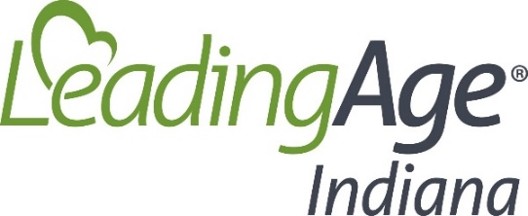

2024 Indiana General Summary Legislative Summary

The 2024 Indiana General Assembly Legislative Session – began on January 8, 2024 and concluded on March 8,2024.

The Session was set to be a slow-paced undertaking, but it started out as anything but that. Right out of the gate, LeadingAge Indiana (LAIN) was faced with multiple Bills that we weighed-in on – some in support of and some of which we opposed (in whole or in part). In the first two weeks, LAIN testified, summited letters to legislators, and engaged with partners on many issues. While we tracked and worked on many issues, at the only two Bills remained. Below is a quick summary of the Bills we watched throughout the Session and the two that made it over the goal line (SB 132 and SB 9). For compete coverage of the Session, click here.

- HB 1414 – main topics: managed care claim payment arrangements and alteration of the 3-year MLTSS any willing provider window.
  - This Bill did not make it to the end.
- HB 1327 – main topics: possible vehicle Bill for helpful prior authorization language.
  - This Bill did not make it to the end.
- HB 1328 – main topics: DLGF Bill that for a while contained property tax exemption language expanding on last year’s achievements.
  - This Bill did make it to the end – and will become law. However, the exemption language was ultimately removed from the Bill.
  - Notably, although the exemption language was removed, there does seem to be some appetite for additional work in this area – which might be a good sign for future discussions with legislators.
- SB 9 – main topics: mergers and acquisition transparency / notification language applicable for members who might engage in this sort of activity for transactions exceeding $10M.
  - This Bill did make it to the end – and will become law.
- SB 132 – main topics: managed care billing, loosening of HFA/RCA licensure requirements.
  - Starting in Section 7, on page 12 of SB 132, this Bill reduced some of the minimum requirements for the HFA and RCA license.
    - An Associate’s, or Bachelor’s degree is no longer required (only a HS diploma);
    - An AIT program is still required to obtain a license, as is passage of s state jurisprudence exam;
      - AIT training hours are different depending on the level of education one has;
    - Notably, in addition to the decrease in formal educational requirements, completion of an HFA (“specialized course”) course is no longer required to obtain a license.
      - It is still permitted to be required by individual LTC communities.
  - This Bill did make it to the end – and will become law.
    - Notably, a main focus of the Bill is the Temporary Emergency Assistance Fund that allows providers adversely affected by the managed care transition (post July 1, 2024) to tap into a state fund to make payroll, etc. There are certain limitations and requirements to participation in the fund however, which providers will need to take part in. These are found starting on page 5 of SB 132.

